Center For Traditional Martial Arts

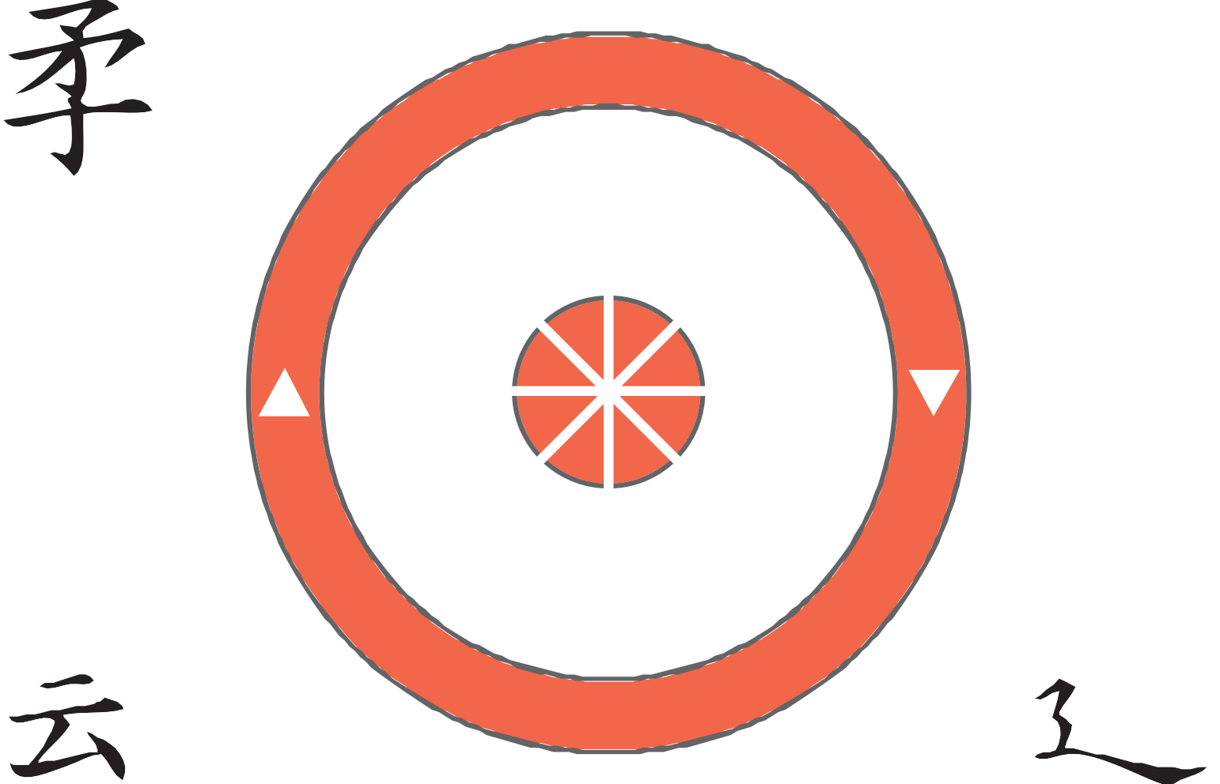
Sensei Ron Smith

www.cftmartialarts.com

About the Center for Traditional Martial Arts

The Center For Traditional Martial Arts is a part of the Jukido-Kai Organization with Eugue- Ryu, a system of karate and jujutsu as its core. The lineage is as follows:

- Kensenzu Yama Eugue – Founder
- Ray Flowers
- Oscar Adams
- Michael Young
- Committee (In the absence of Michael Young)
  - Shane Topp
  - Jeff Fee
  - Perry Wiltsy
  - Rodney Kohler
- Soke Shane Topp (Current Chief, 10th Dan and Head of Eugue Ryu, Head of Jukido Kai Sogo Budo)
- Jukido-Kai Council (In the absence of Shane Topp Sensei) Established January 2021
  - Ron Smith, Mike McCarthy, Bryan Topp, Chester Jones, Chris Headley

Rank System For Jukido-Kai Karate And Jujutsu
Mudansha/Class Rank
Kukyu | 9th Class | White
Hachikyu | 8th Class | Yellow
Shichikyu | 7th Class | Orange
Rokyu | 6th Class | Blue
Gokyu | 5th Class | Green
Yonkyu | 4th Class | Purple
Sankyu | 3rd Class | Brown (3 stripes)
Nikyu | 2nd Class | Brown (2 stripes)
Ikkyu | 1st Class | Brown (1 Stripe)
Shodan | 1st Degree | Black
Nidan | 2nd Degree | Black
Sandan | 3rd Degree | Black
Yodan | 4th Degree | Black
Godan | 5th Degree | Red & Black
Rokyudan | 6th Degree | Red & White
Shichidan | 7th Degree | Red & White
Hachidan | 8th Degree | Red & White
Kudan | 9th Degree | Red
Judan | 10 Degree | Red
**(Smaller white panels for 8th Degree, Panels are the same size for 6th and 7th Degree)
***Joshu-Shodan Junior BlackBelt BlackBelt w/ white
Stripe tip to tip

Yudansha/Degree

Karate Creed

1.)I come to you with only karate, empty hands. I have no weapons, but should I be forced to defend myself, my principles, or my honor; should it be a matter of life or death, right or
wrong, then here are my weapons, karate, empty hands.

2.)I know no kata, but would like to learn!

Four Point Code of Self Protection
- AVOID
- EVADE
- ESCAPE
- ATTACK

Basic Terminology

General Terms Dachi/Stance
Ashi | Foot | Yoi-Dachi | Ready Stance
Ashi-Kubi | Ankle | Kiba-Dachi | Horse Stance
Ashi-No-Ko | Instep | Zenkutsu-Dachi | Forward Leaning Stance
Ashiura | Sole of the Foot | Shiko-Dachi | Sumo Stance
Ashi-Waza | Foot Techniques | Kokutsu-Dachi | Back Leaning Stance
Atemi-Waza | Attack to Vitals | Neko-Dobi-Ashi | Cat’s Paw Stance
Chudan | Middle Level | Hachiji-Dachi | Waiting Stance
Chusoku | Ball of the Foot | Gyaku-Zenkutsu-Dachi | Reverse Forward Leaning
Dan | Degree |  | stance
Dojo | Training Hall | Kumite-Dachi | Sparring Stance
Empi | Elbow | Sanchin Dachi | Hour Glass Stance
Gedan | Lower level
Gi | Uniform | Uke/Defense
Hajime | Begin | Jodan-Uke | Upper Level Block
Hidari | Left | Gedan-Barai | Lower Level Sweep
Hiza | Knee | Chudan-Uke | Middle Level Block
Ibuki | Breathing Techniques | Uchi-Uke | Inside Block
Jodan | Upper Level | Te-Soto-Uke | Knife Hand Block
Jutsu | Art of Combat | Juji-Uke | Cross Block
Kakato | Heel | Mawashi-Uke | Circular Block
Kara | Empty | Kage-Uke | Shadow Block
Karateka | Practitioner of Karate | Age-Uke | Thrusting Block
Kata | Pre-Arranged Forms | Uke Undo | Blocking exercise
Kento | Knuckle | Mawashi Uke Undo | Circular Blocking Exercise
Kiai | Shout of Spirit | Uchi-Soto Undo | Inside/Outside Drill
Kimi | Focus
Kote | Forearm | Tewaza/Hand Techniques
Kumite | Sparring | Gyaku-Tsuki | Reverse Thrust
Kyotsuke | Attention | Oie-Tsuki | Lunge Punch
Kyu | Class Rank | Uraken | Backfist
Mate | Stop | Haito | Ridge Hand
Mawate | 180 Degrees | Tettsui | Hammer Fist
Migi | Right | Agetsuki | Upper Cut
Nage-Waza | Throwing Techniques | Nukite | Spear hand
Obi | Belt | Shotei | Palm Heel
Rei | Respect | Shuto | Knife Hand
Sensei | Teacher | Tegatana | Hand Sword
Shitagi | Trousers | Mawashi-Tsuki | Round House Punch
Tai Sabaki | Body Movements | Empi-Uchi | Elbow Strike
Tamashiwari | Breaking
Te | Hand
Tekubi | Wrist
Ude | Arm
Uwagi | Jacket

Basic Terminology |  |  |  |  | continued
Keri/Kicking Techniques  Kin-Geri | Groin Kick |  | Method Of Counting  Ichi | 1
Mae-Geri | Front Kick |  | Ni | 2
Yoko-Geri | Sidekick |  | San | 3
Mawashi-Geri | Round House Kick |  | Shi | 4
Ushiro-Geri | Back Kick |  | Go | 5
Kakato-Geri | Heel Kick |  | Rokyu | 6
Mikkatsuki-Geri | Crescent Kick |  | Shichi | 7
Hiza-Geri | Knee Kick |  | Hachi | 8
Tobi-Geri | Jump Kick |  | Ku | 9
Kekomi Geri | Thrusting Kick |  | Ju | 10
Keage Geri | Snap Kick |  | Ju-ichi | 11
Ura Geri | Spin Kick |  | Ju-Ni | 12
Kakato Otoshi Geri | Axe Kick |  | Ju-San | 13
 |  |  | Ju-Shi | 14
Ukemi/ Breakfalls |  |  | Ju-Go | 15
Mae-Ukemi | Forward Breakfall |  | Ju-Rokyu | 16
Yoko Ukemi | Sideways Breakfall |  | Ju-Shichi | 17
Ushiro-Ukemi | Backwards Breakfall |  | Ju-Hachi | 18
Kaiteri-Ukemi  Yoko Kaiteri Ukemi Ushiro Kaiter Ukemi | Rolling Breakfall  Sideways Rolling Breakfall Backward Rolling Breakfall |  | Ju-Ku Ni-Ju | 19
 |  |  | …..ETC
 |  |  | San-Ju | 30
 |  |  | San-Ju-Ichi | 31
 |  |  | Hyaku | 100

Rules and Regulations

Dress and Appearance
- Proper uniforms(gi) are encouraged as attire for class.
- All uniforms are to be kept CLEAN and in GOOD REPAIR.
- A protective cup is required for all male students.
- No jewelry is to be worn during class.
- Long hair must be tied back.
- Fingernails and toenails are to be kept trimmed.
- The only thing allowed on the uniform (gi) is the approved class patch. All other marks or identifying tags must be removed from the uniform. If there is any questions about what’s allowed on the uniform (gi) please feel free to ask.

Student Conduct
- Respect and discipline are to be maintained at all times.
- Students should be mindful of the premises and equipment. Keep the premises and the equipment clean and in good repair.
- No talking during class.
- If you arrive late to class, report to the instructor before joining class.
- If a class is in session and you need to leave, report to the instructor as well.
- You should arrive no more than 15 mins. before class unless other arrangements have been made with the instructor.
- No horseplay in the dojo.
- No foul language.
- Do not bring food or drink into the training area of the dojo.
- During the school year, passing grades are required and report cards must be shown to the instructor.

Visitor/Parent Conduct
- Loud talking is not permitted during class.
- Do not drop your child off more than 15 mins. before class.
- Pick up your child immediately after class.
- Small children are not allowed to roam freely. Remember, this is a martial arts school.
- No food is permitted in the training area of the dojo.
- There should be no interference from anyone during class unless requested by the instructor.
- Please turn all cell phones to silent mode, vibrate, or off during class.

Rules and Regulations
continued

Additional Requirements
- All fees must be paid during the first week attended every month. A late fee of $5 will be assessed after the first week attended. If you have a financial hardship, see Sensei Smith to discuss your options
- Classes do not roll over into the next month. If a student doesn’t attend class for any reason, please try to make it up by coming on another night or possibly attending multiple classes in one day.
- Waivers are required for all participation.
- Alcohol and/or drug abuse will not be tolerated.
- At any time, the instructor may expel any Jukido Kai student from class for conduct unbecoming of a student.
- It may be necessary from time to time for a student to pay for a single class. A $12 fee is required for a single class. (Zanesfield)

Refund Policy-Zanesfield Location
A fifty percent refund will be given prior to the first scheduled class after registration. No refund will be issued after your first scheduled class, whether class was attended or not. This refund policy also applies in the event of an expulsion or private instructor registration.
All fees are non-transferable, even between family members.

Quarterly Payment Option-Zanesfield Location
We offer a discount of $10 on enrollment fees to those who are willing to commit to 3 months at a time. The quarters are set as .....Discounts can only be applied if a student’s account is up to date.

1st quarter = Jan, Feb, Mar 2nd quarter= Apr, May, June 3rd quarter= July, Aug, Sept 4th quarter= Oct, Nov, Dec

Family Discount-Zanesfield Location
We love for family members to get fit and learn together. The Center for Traditional Martial Arts offers a $5 discount per person, per class enrolled in for members who reside in the same household. This applies to most classes available. Example: 2 students in the same household-Both get a $5 discount as long as their account is up to date.

Promotion Fees
From time to time a student will be ready for promotion to a higher rank. When your Sensei feels that a student is ready his/her name will appear on a promotion list which is located in the “Testing” section on our website. When the student or the students parent feels they are ready to test you pay the promotion fee which in turn will allow Sensei to begin the testing process anytime thereafter. Please see Sensei for a list of promotion fees.

Snow Day/ Cancellations
Occasionally, classes maybe cancelled due to inclement weather. If Bellefontaine City Schools cancel DUE TO SNOW AND/OR ICE, classes will also be cancelled. If you have any questions as to a class being cancelled, visit www.cftmartialarts. com . The cancellation will be listed on the top of the Main Page. It can also be heard on 98.3 wpko. If your email is up to date you will receive one via email. You may also text Sensei Smith at (937)539-6751 or email him at jukidowarrior@yahoo.com .

